1
- Janie B- Bruce C-Dave

2. A –since it maximizes profit by equating marginal revenue to marginal cost.
3. a) Tres Amigos and Matyrs
b). Dog and Matyrs
c) Tres Amigos
4. A and B
5. D
6. Expectation of cheating = Probability cheating * Pay off (mean)
= 0.6 *30
= 18
Students are not rationally acting as cheating is an examination malpractice
I would encourage other resourceful discourses that would discourage cheating and also introduce a price for not cheating

7. C and E
8. B
9.
10.
11 a
12 d

ESSAY Questions
- a. 22,500 /( 1.35)²⁰ = $1375
b. The government need to adopt the plan courtesy of the profit accumulations
c. It won’t change as it would remain in the same profit range
D. At 20%
2. A) PNC have a dominant strategy that involve the rise in the rates and keeping the industry rates level
b. If player two chooses cooperate, player one should choose cheat ($900 versus $ 840)
• If player two chooses cheat, player one should also cheat ($700versus $800). Therefore, the optimal strategy is to always cheat (for both p
c. I won’t do a policy maker as it may impact back negatively since it does not put into effect the real incidents on the ground.
3. R2 means that there is a relationship between the revenue and expenditure by the federal government. The performance of the government lies squarely on policies.

4
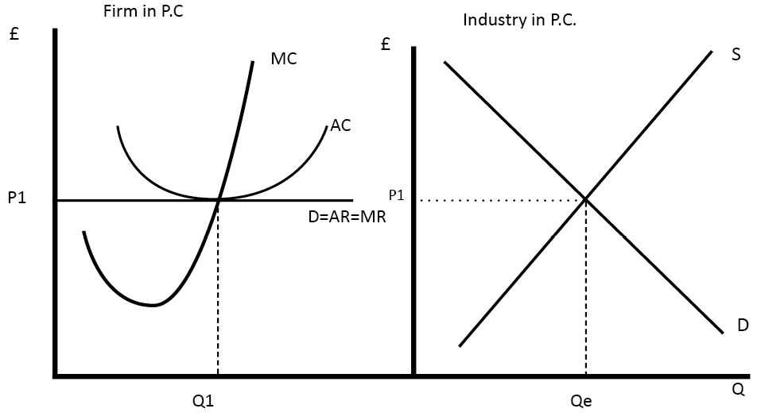

Increase in the sales tax leads to reduction in revenue for the businesses. In the event, the two parameters are dependent on other inversely.

5. a. Third party is any market player in the industry other than Avengers
b. The avengers need to be given time to think on the best strategy forward and not being imposed on decisions.

c) To allow time value of an investment
d)
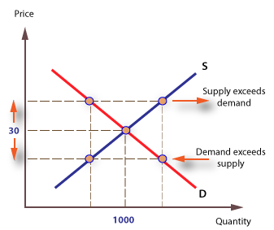

6.
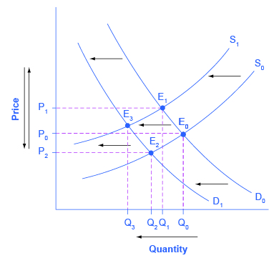
.
9. a. 3 and 30
b. 4
c.40

10. b and d

